Andrew Dalia (dalia@cooper.edu) and Samuel Windwer (windwe@cooper.edu)
Databases Project Proposal

The overall objective of this project is to create a schedule tracking system for a theoretical large (possibly multinational) company. Accordingly, the requisite database will be used to store information about the employees and the shifts that they work. This system will be used to coordinate schedules between different locations and different groups to ensure that there is a proper workforce on duty everywhere at all times. Only managers have permission to create and modify the schedule, but all employees are allowed to view the schedule.
Due to the enormity of the company, all of its locations operate for 24 hours a day (each day is divided into three eight-hour shifts). Additionally, employees can be members of different groups within the company (for example, there may be a Windows, Macintosh, and UNIX team in a software company). Further, there is a distinction between managerial employees and non-managerial (so-called “regular”) employees.
The entity-relationship (ER) diagram for our proposal is shown below.
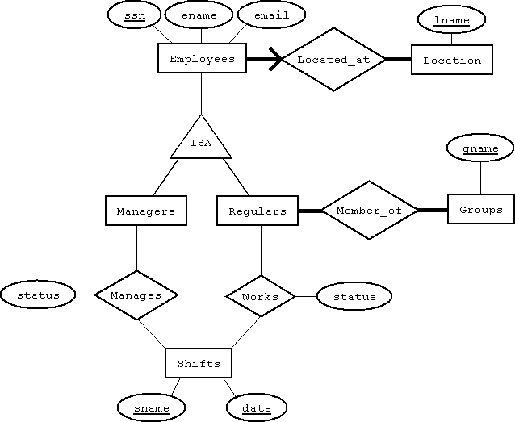
This diagram exemplifies the overall structure that the database will have.
Most of the attributes of the entity and relationship sets are pretty self explanatory, but a few warrant additional explanation. Namely, the “sname” attribute of the “Shifts” entity set can only take on one of three values: morning, afternoon, or night. These values are used to represent the three shifts for each day. Additionally, the “status” attribute of the “Manages” and “Works” relationship sets can only take on one of four values: in, out, vacation, or sick. The function of this attribute is explained in the middle of the next paragraph.
In regards to integrity constraints, the ER diagram indicates that every regular employee must be a member of at least one group, every group must have at least one regular employee as a member, every employee is located at exactly one location, and every location has at least one employee located there. However, it is not able to illustrate any of the other integrity constraints that we plan to provide. An additional constraint which we will enforce at the application level is that every “Manager” and “Regular” must be associated with every “Shift” through the “Manages” or “Works” relationships, respectively. It is the “status” attribute that indicates if the employee is actually working that shift (in), not working that shift (out), on vacation during that shift (vacation), or sick during that shift (sick). In other words, every Employee/Shifts combination needs to have at least one entry in the “Manages” or “Works” relation and the status indicates if they are actually working. The reason for doing it this way is so that an employee will not be accidentally scheduled to work a shift that they have off.
Another constraint which we will implement is that every shift at every location needs to have at least one manager on duty at all times. Additionally, there must be at least one “Regular” that is in for each group during every shift at every location. We assume that the managers are in charge of all groups within the company so that they do not count towards the requirement of the minimum workforce for each individual group. Therefore, only the “Regulars” employed in a group during any given shift will count towards this total.
The interface will give employees the ability to flexibly search the schedule based on various criteria. The employees will be able to view schedules according to group, shift, and date. Furthermore, by specifying more than one parameter in a search, employees can receive more refined results. For example, they should be able to receive the status of employees working in the “Windows” group for the “morning” shift for “February 29, 2012” by specifying the appropriate group, shift, and date. Another possible view would be that of all employees in any group with in status on “December 31, 2009”, which could be found by searching for the right status and date. Therefore, we hope to keep schedule viewing as customizable as possible among the fields of date, status, group, and shift.
The managers can edit schedules as well as view them. Accordingly, they will have access to a specialized interface to do this. When staffing a particular shift at a particular location, managers will be able to easily view the statuses of all the employees in order to see who is available, who is already working, and who is away on vacation.

